# Analogies

Same like in a hotel, once we show our ID card(aadhar card/voter card) we will get a hotels access card,

With that we can go to swimming pool, GYM,SPA, depending upon the amount we paid, we will get access to those areas

If we would have paid more amount, we will get access to all room,GYM,SPA,Swimming pool

And that access card is only valid for 2-3 days

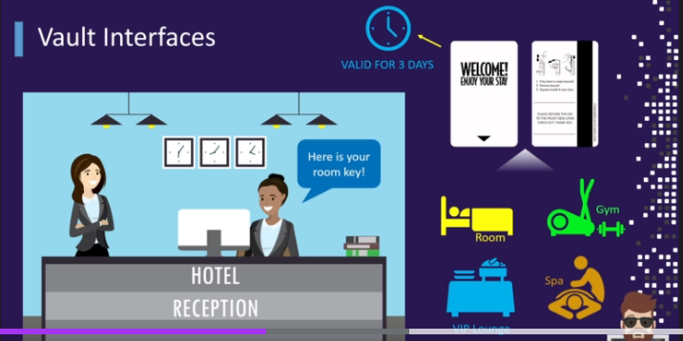

Same like in vault also, we provide our credentials and we will get a token which is valid for some time

Same like depending upon amount we pay, we will get access to those areas,

Here also we will be getting a token , that token is only to access to some paths like venafi certificate path

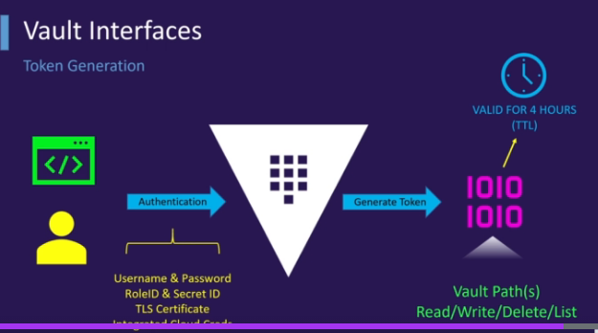

Here also that valut given token is not for all areas,this is only for few areas

If u communicate using credentials, sniffer’s can catch and use them later, whereas, if u communicate using token

Even if they catch also,it might be valid only for 10-15 mins,

So only 1st time we authenticate using credentials, next time onwards only we use token

## Benefits of Hashi corp vault

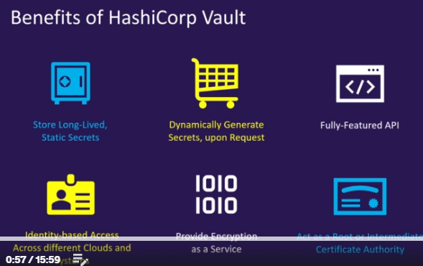

### Benefits of Dynamic passwords

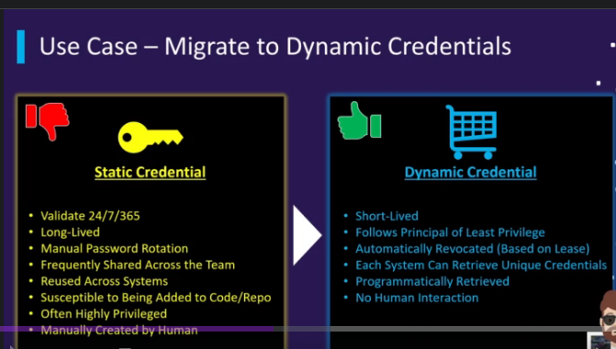

If one team member knows that password, all others will share among everyone

So recommended to use dynamic passwords, because these are automatically deleted after 3-4/6/12 hours

So that even if someone knows also no issue,

These dynamic credentials can be retrieved using API

### Opensource vs Enterprise version

